SET 1

Q1. (Data Structures – 5 Marks)
Using AI assistance, write a Python program to implement a Stack using a list.
Perform the following operations:
- Push 5 elements
- Pop 2 elements
- Display the remaining stack
Explain how AI helped generate or optimize your structure.
- CODE:
- 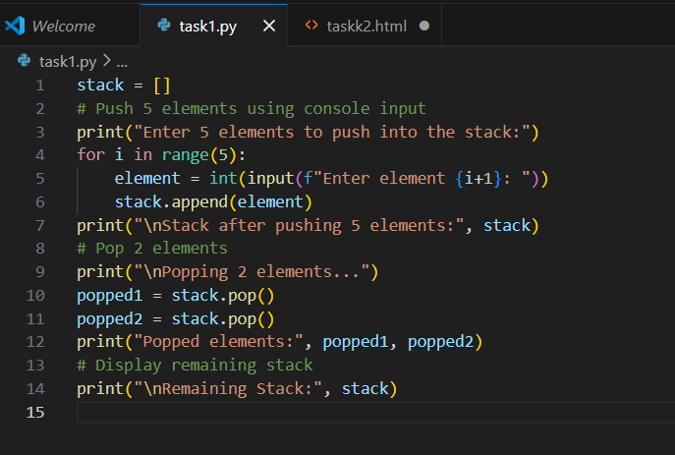
- OUTPUT:
- 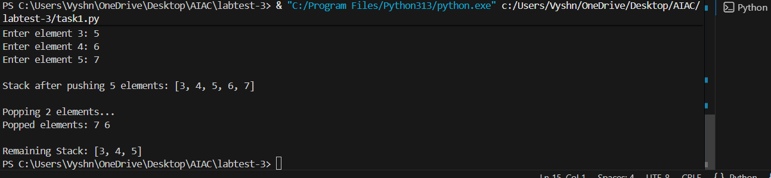

Q2. (Web Frontend – 5 Marks)
With AI tools, develop an interactive To-Do List App using HTML, CSS, and JavaScript.
Include features:
- Add task
- Delete task
- Mark as completed
- CODE:
- 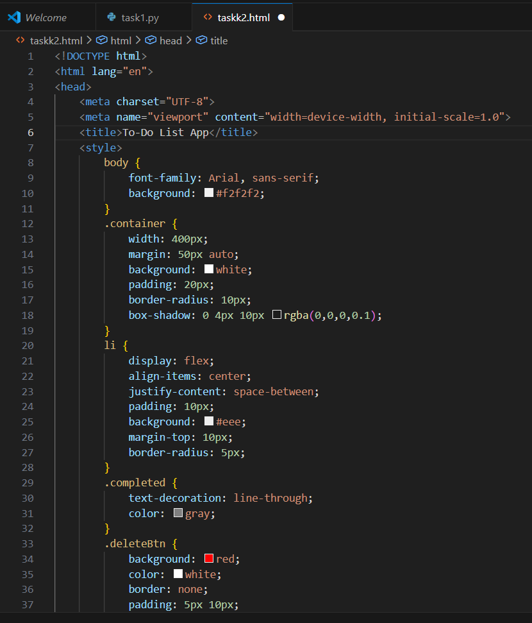
- 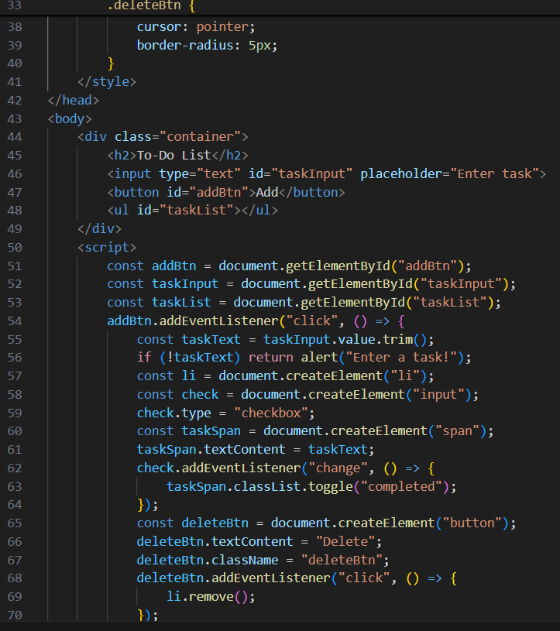
- 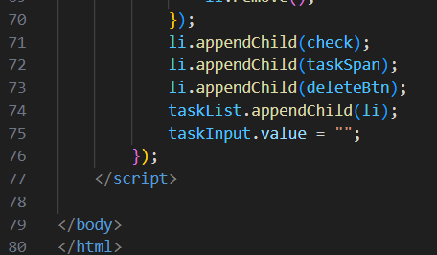
- OUTPUT:
- 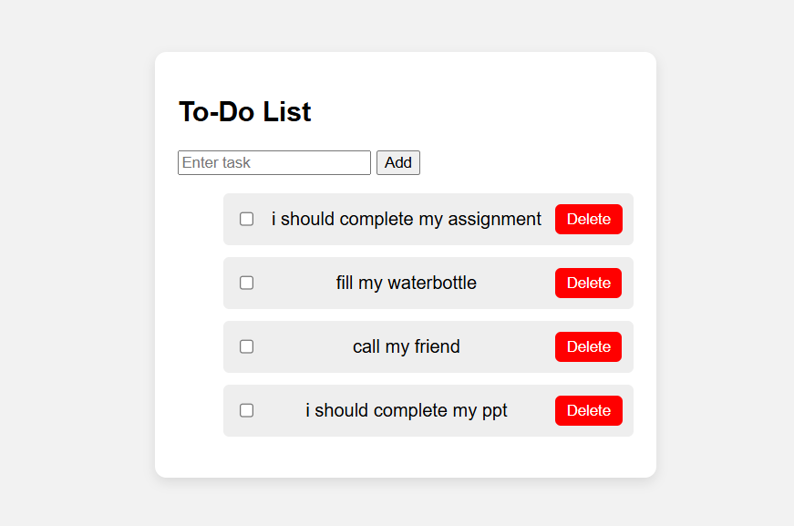
=====================================================================================

SET 2

Q1. (Algorithms – 5 Marks)
Using AI assistance, generate Python code to implement Merge Sort.
Run the algorithm on the list: 45, 12, 3, 67, 34, 21.
Explain the time complexity and how AI improved correctness.

Q2. (Web Frontend – 5 Marks)
Use AI to generate a webpage showing a student registration form with:
- Input fields (Name, Email, Course)
- Submit button
- JavaScript form validation

============================================================

SET 3

Q1. (Data Structures – 5 Marks)
Use AI to create a Python program implementing a Queue using the collections.deque module.
Perform:
- Enqueue 4 values
- Dequeue 1 value
- Display queue
Explain AI’s suggestion accuracy.

Q2. (Algorithms – 5 Marks)
With AI assistance, implement Binary Search in Python.
Test it on the sorted array:
[10, 20, 30, 40, 50, 60] to search for the number 40.

============================================================

SET 4

Q1. (Algorithms – 5 Marks)
Use AI to generate Python code for Bubble Sort and Insertion Sort.
Compare their execution time using Python's time module.

Q2. (Web Frontend – 5 Marks)
With AI help, create a webpage showing a dynamic product list using JavaScript arrays.
Each product must display:
- Name
- Price
- "Add to Cart" button
=====================================================================

SET 5

Q1. (Data Structures – 5 Marks)
Using AI tools, implement a Linked List in Python with operations:
- Insert at beginning
- Insert at end
- Delete a node
Display the list after operations.

Q2. (Web Frontend – 5 Marks)
With AI assistance, generate a responsive Portfolio Website Layout including:
- Header
- About section
- Projects section
- Contact form

